DECLARATION
I, EBENDA ASSENE MARTHE DAVIDA, hereby declare that this project entitled DESTINATION VISUALIZATION AND VERIFICATION SYSTEM FOR CUSTOMS GOODS ( DouaneNav) is my original work and was carried out by me in partial fulfilment of the requirements for the award of the Bachelor's Degree in Software Engineering.
All ideas, analyses, designs, implementation, testing, and documentation presented in this report are my own except where the work of other authors has been acknowledged through appropriate references in accordance with academic standards.
I further declare that this work has not been submitted, either wholly or in part, to any other institution for the award of any academic qualification.
NAME: EBENDA ASSENE MARTHE DAVIDA
Signature: _______________________________
Date: ___________________________________

CERTIFICATION
This is to certify that the project entitled DESTINATION VISUALIZATION AND VERIFICATION SYSTEM FOR CUSTOMS GOODS (DouaneNav) was carried out by EBENDA ASSENE MARTHE DAVIDA under my supervision and was examined and approved for submission to the Department of Software Engineering in partial fulfilment of the requirements for the award of the Bachelor's Degree in Software Engineering.
SUPERVISOR: ______________________________________
Signature: ________________________________________
Date: _____________________________________________

DEDICATION
This project is dedicated to my beloved family for their unwavering love, sacrifices, encouragement, and continuous support throughout my education.

ACKNOWLEDGEMENT
My sincere appreciation goes to my academic supervisor, Engr. ABANJI DIEUDONNE, for his invaluable guidance, constructive advice, and continuous support throughout this project.
I am equally grateful to my field supervisor and the management and staff of the Cameroon Customs (Direction Générale des Douanes du Cameroun) for their cooperation, practical guidance, and the opportunity to gain valuable professional experience during my internship.
I also express my sincere gratitude to the Higher Institute of Technology and Management (HITM-CITEC) for providing the academic environment and resources necessary for my studies. I equally appreciate the lecturers of the Department of Software Engineering for the knowledge and guidance they provided throughout my academic journey.
Finally, I extend my heartfelt appreciation to my parents, Assene Hubbert Marcel and Assene Henriette Juliana, as well as my family, friends, and classmates for their unwavering encouragement, prayers, and support throughout my academic journey.

ABSTRACT
For a single shipment, a Cameroonian customs officer must consult several independently produced documents, the CAMCIS customs declaration together with a bill of lading, invoice, packing list, and transport company particulars, to determine a shipment's declared destination. This information is not presented visually, so officers spend time manually cross-referencing documents, and customs officers in the field have limited advance visibility of that destination.
This study proposes DouaneNav, a mobile-first decision support subsystem that complements CAMCIS rather than replacing it. A React Native mobile application, the system's main operational tool, retrieves declaration information, simulated locally during development and drawn from CAMCIS in production, allows search by declaration number or truck plate, visualises the declared destination on Google Maps, and lets officers record inspection outcomes with photographs and comments. Completed reports are designed to be synchronised back to CAMCIS once authorised, with failed synchronisations retried automatically. A lightweight React.js web dashboard supports Administrators and Supervisors with user management, synchronisation monitoring, and statistics. AI-based document analysis is architected but implemented as a future-phase enhancement. The backend uses Node.js, Express, MongoDB, and JWT-based role-based access control.
The study assesses the feasibility of this design and the functionality of map-based visualisation and report synchronisation for customs field operations, contributing a locally relevant model for complementing national customs platforms rather than duplicating them.
Keywords: Customs Digitisation, CAMCIS, Destination Visualisation, Mobile Decision Support, Inspection Support, Google Maps, Synchronisation, Cameroon.

RESUME
La vérification de la destination déclarée d’une marchandise représente un défi pour les agents des douanes camerounaises, car les informations nécessaires sont réparties dans plusieurs documents tels que la déclaration CAMCIS, la facture, le connaissement, la liste de colisage et les informations du transporteur. Cette situation oblige les agents à effectuer des vérifications manuelles et limite la visibilité des agents des douanes lors des opérations de contrôle sur le terrain.
Ce projet présente DouaneNav, un sous-système mobile d’aide à la décision conçu pour compléter CAMCIS sans le remplacer. L’application mobile développée avec React Native permet aux agents de rechercher les déclarations douanières, de consulter les informations relatives aux marchandises, de visualiser les destinations déclarées sur une carte numérique et d’enregistrer les résultats des inspections avec des commentaires et des photographies.
Le système comprend également un tableau de bord web destiné aux administrateurs et superviseurs pour la gestion des utilisateurs, le suivi des synchronisations et la consultation des statistiques. L’architecture repose sur un backend développé avec Node.js, Express et MongoDB, intégrant une authentification sécurisée basée sur JWT et une gestion des accès selon les rôles. Le module d’analyse documentaire utilisant l’intelligence artificielle est prévu comme une amélioration future.
Les résultats obtenus montrent que DouaneNav fournit une solution adaptée pour améliorer l’accès aux informations douanières, faciliter la préparation des inspections et renforcer la fiabilité des rapports produits sur le terrain. Le projet démontre ainsi la possibilité de compléter les plateformes nationales existantes par des outils mobiles spécialisés répondant aux besoins opérationnels des agents.
Mots-clés : Douanes camerounaises, CAMCIS, Visualisation des destinations, Application mobile, Inspection, Synchronisation, Système d’aide à la décision.

CHAPTER ONE: INTRODUCTION
This chapter introduces the study of DouaneNav, a mobile-first decision support subsystem for visualising declared destinations and supporting field inspections within the Cameroonian customs environment. It presents the historical, conceptual, theoretical, and contextual background of the study, followed by the problem statement, objectives, research questions, significance, justification, delimitation, and organisation of the study.

Background of the Study

1.1.1 Historical Background
Customs control has, for centuries, depended on paper documentation as proof of the origin, nature, and destination of traded goods. Cameroon Customs first computerised its declaration process in 1984 with PAGODE (Procédures Automatisées de Gestion des Opérations de la Douane et du commerce Extérieur), a system that operated principally in the Littoral customs sector around the port of Douala and, at its peak, processed the large majority of the country's customs revenue. Over roughly two decades of use, PAGODE became increasingly difficult to maintain and update, and by the early 2000s it no longer met the technical requirements of a modernising customs administration.
Following pilot deployments between 2004 and 2006, Cameroon Customs officially replaced PAGODE with SYDONIA, the French designation for the Automated System for Customs Data (ASYCUDA, or Système Douanier Automatisé), a customs declaration-processing system owned and maintained by the United Nations Conference on Trade and Development (UNCTAD), the United Nations body responsible for trade and development policy. SYDONIA (specifically its SYDONIA++/ASYCUDA++ version) became Cameroon's core declaration-processing platform from 1 January 2007. While SYDONIA represented a substantial improvement over PAGODE, automating the full declaration lifecycle for the first time, it had originally been designed for statistical purposes and, despite later enhancements, showed limitations in fully supporting clearance procedures as trade volumes grew (Direction Générale des Douanes, n.d.).
On 5 June 2020, Cameroon's Minister of Finance officially launched CAMCIS as the successor to SYDONIA. CAMCIS is a modern, web-based, client-server platform developed under a public-private partnership signed in September 2015 between the Government of Cameroon and CAMPASS, a company backed by Korean capital and technical expertise, with the system modelled on the UNI-PASS platform used by the Korea Customs Service. CAMCIS was introduced to accelerate clearance, reduce face-to-face engagement and associated opportunities for fraud, and allow remote, browser-based access to customs procedures.
Although CAMCIS automates the processing of customs declarations, this study explores the development of a complementary, mobile-first subsystem dedicated to destination visualisation and field inspection support, in order to further assist customs officers operating away from the point of declaration. The more recent emergence of accessible mapping platforms and mobile development frameworks has made it practical to build such a subsystem at reasonable cost, with AI-assisted document analysis identified as a natural, and architecturally accommodated, future extension.

1.1.2 Conceptual Background
A customs declaration is a formal statement made to a customs authority describing goods being imported, exported, or moved in transit; in Cameroon, this declaration is now recorded and processed within CAMCIS. Alongside the declaration, a shipment is typically accompanied by several further documents produced independently of CAMCIS: a bill of lading or transport document, issued by the carrier and recording the consignor, consignee, and destination of the shipment; a commercial invoice, issued by the supplier; a packing list, detailing the contents of the consignment; and transport company particulars identifying the carrier responsible for moving the goods.
In this study, retrieval refers to the process by which declaration information is accessed and reused by DouaneNav: simulated locally during development, since the student does not have authorised access to the live CAMCIS platform, and drawn directly from CAMCIS once an official integration is authorised. Synchronisation, by contrast, refers to the reverse process, by which a completed inspection report is transmitted from DouaneNav back to CAMCIS. These two flows are deliberately asymmetric: the subsystem only ever reads declarations from CAMCIS and only ever writes inspection reports to it; it never modifies a declaration.
Geographic visualisation refers to the representation of a declared destination on an interactive digital map rather than as plain text, drawing on the map-first, route-oriented presentation style popularised by consumer navigation applications such as Citymapper, adapted here to a customs field-operations purpose. Within DouaneNav, this visualisation is the subsystem's central, standalone mission, since presenting a destination visually, rather than as a line of text within a declaration, is what allows an officer to grasp it at a glance and plan an inspection accordingly.
Conceptually, the operation of DouaneNav can be described as a single continuous workflow. A declaration is first created and validated within CAMCIS, as is already the case today. DouaneNav then retrieves the information relevant to that consignment, including the declaration number, importer, transport company, truck and driver particulars, declared destination, and current status, from CAMCIS in production or from a simulated equivalent dataset during development. The declared destination is converted into geographical coordinates through a geocoding step, so that a destination such as Odza is resolved to a specific latitude and longitude and displayed directly on an interactive map, rather than remaining a line of text. An officer can then search by truck registration plate or declaration number and immediately view the destination, map, and any existing inspection history for that consignment. Following a field inspection, the officer records the outcome, comments, photographs, date, and location directly within the mobile application; this report is stored locally and subsequently synchronised back to CAMCIS once an authorised connection exists. Throughout this workflow, the truck and driver particulars retrieved from CAMCIS serve only to identify a specific declared consignment for search and inspection purposes; they do not constitute continuous GPS tracking of the vehicle, which remains outside the scope of this study, as stated in the delimitation below.
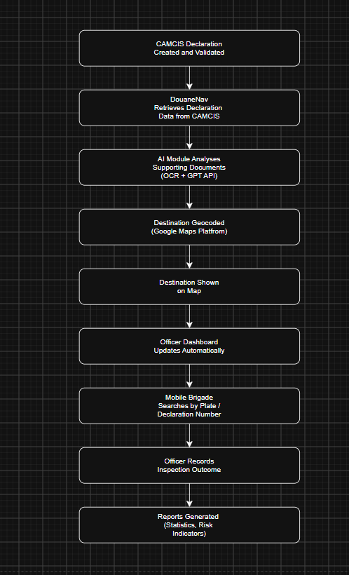
Figure 1.1: DouaneNav end-to-end operational workflow, from CAMCIS declaration to synchronised inspection report.

1.1.3 Theoretical Background
This study is grounded in Decision Support System (DSS) theory, first articulated in 1971 by Anthony Gorry and Michael Scott Morton of the MIT Sloan School of Management, who classified organisational decisions as structured, semi-structured, or unstructured, and argued that computer-based systems provide the greatest value when applied to semi-structured problems where routine elements can be automated while final judgement remains with the human decision-maker. Locating a shipment's declared destination and deciding whether to inspect it is precisely such a task: retrieval and visualisation can be automated, while the decision to inspect, and the interpretation of what is found, remain the responsibility of the officer.
The study also draws on the theory of bounded rationality, developed by Herbert Simon (1916 to 2001), a Nobel Laureate in Economic Sciences whose work spans economics, cognitive science, and administrative decision-making. Bounded rationality recognises that human decision-makers operate under real limits of time, information, and cognitive capacity. Manually cross-referencing several documents per consignment, particularly away from the point of declaration, exceeds what an officer in the field can reliably do without support. DouaneNav is designed to offload the mechanical work of retrieval and visualisation to the system, so that officers can direct their limited attention toward the inspection itself.
Finally, the study draws lightly on Human-Computer Interaction (HCI) principles of mobile interface design, which hold that a field-oriented application should surface the smallest set of high-relevance actions, search, view destination, inspect, rather than the full underlying data set, so that an officer working under time pressure and variable connectivity can act quickly and correctly. This principle informs the design of both the mobile application and the officer-facing dashboard described in later chapters.

1.1.4 Contextual Background
Cameroon is served principally by the seaport of Douala, the country's main commercial gateway, and the deep-water port of Kribi, alongside land border posts and inland customs offices. Cameroon Customs (Direction Générale des Douanes, DGD) processes a substantial volume of import, export, and transit declarations daily, many of which relate to onward transit toward neighbouring landlocked countries such as Chad and the Central African Republic, using CAMCIS as its core declaration-processing platform. In this environment, officers are frequently deployed away from the point of declaration and rely on secondary information to decide where and when to inspect goods in transit.
Cameroon's growing smartphone and internet penetration, together with the increasing digitisation of trade documentation under CAMCIS, creates a practical opportunity to deploy a complementary, mobile-first decision-support tool of this kind. This study assumes that customs declaration information will, in production, be available from CAMCIS, and is simulated locally for the purposes of development and evaluation. A system that retrieves declaration data, presents the result as an interactive map, and supports structured field inspection is both technically feasible within the current infrastructure and directly relevant to the operational needs of customs officers.

1.2 Statement of the Problem
For a single shipment, a customs officer may need to consult a considerable volume of information spread across several documents: the CAMCIS customs declaration, a bill of lading or transport document, a commercial invoice, a packing list, and transport company particulars. The destination of the goods exists somewhere within this set of documents, but it is not presented to the officer in an intuitive, visual way. As a result, officers spend time opening each document in turn, reading the information it contains, identifying where the goods are expected to go, and organising inspection activities accordingly. This process is manual, repeated for every consignment, and can slow down operational work, particularly at high-volume entry points.
A further consequence is that custom officers, who conduct inspections away from the point of declaration, often have limited advance visibility of the destination that goods are officially expected to reach. This reduces the efficiency of inspection planning. Additionally, after an inspection is completed, findings are often recorded through separate reporting methods, creating difficulties in maintaining a structured and synchronised link with the original declaration. Although CAMCIS provides automation for customs declaration processing, there is currently a need for a complementary decision-support solution that can retrieve declaration information, present declared destinations through interactive map visualisation, support structured field inspection with photographic evidence, and facilitate synchronisation of authorised inspection reports.
Therefore, this study focuses on the design and development of DouaneNav, a mobile-first decision support subsystem that complements CAMCIS by improving destination visibility, supporting customs field inspections, and enhancing the management of inspection information through digital reporting and synchronisation mechanisms.

1.3 Objectives of the Study

1.3.1 Main Objective
The main objective of this study is to design and develop DouaneNav, a mobile-first decision support subsystem connected to CAMCIS, whose mission is to retrieve declaration information, visualise declared destinations on an interactive map, assist Customs Officers during field inspections, and synchronise completed inspection reports back to CAMCIS, supported by a lightweight web dashboard for administration, without replacing CAMCIS itself.

1.3.2 Specific Objectives
- To design a mechanism for retrieving relevant customs declaration information, simulated locally during development, for use within the DouaneNav mobile application.
- To implement search functionality allowing officers to locate a declaration by declaration number, truck plate, importer, destination, or date.
- To visualise the retrieved destination on an interactive map built on the Google Maps SDK, presenting it as a central, standalone feature of the mobile application.
- To implement an inspection module allowing Customs Officers to record inspection outcomes, including results, comments, and photographs, against a specific declaration.
- To design a synchronisation mechanism that stores completed inspection reports locally and transmits them back to CAMCIS once an authorised integration exists, retrying automatically on failure without ever deleting the report.
- To design a lightweight web dashboard enabling Administrators to manage users and system configuration, and Supervisors to monitor inspections, synchronisation status, and operational statistics.
- To implement authentication and role-based access control (RBAC) distinguishing Administrators, Customs Officers, and Supervisors, and to test and evaluate the resulting system.

1.4 Research Questions

1.4.1 General Research Question
How can a mobile-first decision support subsystem, connected to CAMCIS, combine destination visualisation, field inspection support, and report synchronisation to improve customs officers' field operations in Cameroon?

1.4.2 Specific Research Questions
- How can relevant declaration information be retrieved from CAMCIS, or simulated equivalently during development, for use within a mobile decision support application?
- How can the Google Maps SDK be integrated to represent a declared destination in a way that is useful to Customs Officers in the field?
- How can an inspection module be designed to allow officers to record results, comments, and photographs against a declaration efficiently, including under limited connectivity?
- How can completed inspection reports be synchronised reliably back to CAMCIS, including automatic retry of failed synchronisations?
- What web dashboard design most effectively supports Administrators and Supervisors in managing users, monitoring synchronisation, and reviewing operational statistics?
- What architecture would allow an AI-powered document analysis module to be added as a future enhancement without requiring redesign of the core system?
- What system architecture and access-control model are most appropriate for a scalable, secure subsystem that integrates with CAMCIS?

1.5 Significance of the Study

1.5.1 To Customs Administration
The system offers customs administrators a centralised, auditable record of inspection activity and synchronisation outcomes, supporting more consistent field operations and reducing reliance on unstructured, paper-based inspection reporting.

1.5.2 To Customs Officers
By presenting destination information geographically and supporting structured, photograph-backed inspection recording, the system gives officers in the field improved visibility of where goods are declared to be going and a faster, more reliable way to document what they find.

1.5.3 To Importers and Clearing Agents
More efficient, better-targeted inspection planning can reduce unnecessary delays experienced by importers and clearing agents whose consignments would otherwise be subject to less-informed field checks.

1.5.4 To Researchers and the Academic Community
This study contributes to the growing body of research on mobile-first decision support tools for customs and trade-facilitation contexts in developing countries, and provides a model, including its bidirectional synchronisation approach, that future researchers in similar contexts can build upon.

1.6 Justification of the Study
CAMCIS already performs the processing of customs declarations in Cameroon and is expected to remain the country's principal customs platform. DouaneNav does not seek to replace CAMCIS; rather, it acts as a mobile-first companion subsystem connected to CAMCIS, whose mission is to retrieve declaration information, visualise destinations, support field inspections, and synchronise completed reports back to CAMCIS, functions that are not understood to fall within CAMCIS's current scope. Replacing or re-architecting a national platform such as CAMCIS would be a large-scale governmental undertaking beyond the scope of any single project; building a complementary subsystem alongside it is both more realistic and more immediately useful.
The increasing availability of mature, affordable mobile development frameworks and mapping platforms, together with the digitisation of declaration data already achieved through CAMCIS, makes this an appropriate moment to pursue such a subsystem. No comparable subsystem specifically targeting mobile destination visualisation, field inspection support, and report synchronisation, built to complement CAMCIS, currently exists within the Cameroonian customs context, which further supports the originality and relevance of this study.

1.7 Delimitation of the Study

1.7.1 Thematic Scope
This study is limited to the design and development of a mobile-first decision support subsystem that retrieves declaration information, visualises destinations on a map, supports structured field inspection, and synchronises completed inspection reports back to CAMCIS, together with a lightweight companion web dashboard. It does not attempt to replace or re-implement CAMCIS's declaration-processing functions, nor does it provide continuous GPS-based vehicle tracking, payment processing, or automated risk-scoring. AI-powered document analysis is architected but not implemented within the present study; it is identified as a future-phase enhancement rather than a feature of the present system.

1.7.2 Geographical Scope
The application is designed with particular reference to customs operations in Cameroon, including the ports of Douala and Kribi and associated inland and transit routes. While the underlying approach could in principle be applied in other customs jurisdictions facing similar challenges, the design, development, and evaluation described in this study are limited to the Cameroonian context.

1.7.3 Time Scope
This study was conducted between June and September 2026. Background research and the Citymapper concept adaptation study were completed in June 2026, alongside the drafting of the Abstract, Chapter One, and Chapter Two. An internship at Cameroon Customs (Direction Générale des Douanes), Technical Service (Service Technique), Yaounde, took place between 22 July and 30 August 2026, during which further requirements validation and technical exposure informed the system's design. System design, development, and testing were carried out in parallel with, and following, the internship, with the final report submitted by 15 August 2026 and an oral defence scheduled for September 2026. Subsequent enhancements or large-scale deployment fall outside the scope of the study.

1.8 Organization of the Study
This report is organised into five chapters. Chapter One presents the introduction and background of the study, including the problem statement, objectives, research questions, significance, justification, and delimitation. Chapter Two presents a review of related literature covering theoretical, conceptual, and empirical perspectives, together with the project management plan and a presentation of the host institution.
Chapter Three describes the research methodology, including the research design, feasibility studies, population and sampling framework, and data collection and analysis methods. Chapter Four presents the implementation of the DouaneNav system and the results of its testing and evaluation. Chapter Five presents the discussion of findings, conclusions, policy implications, and recommendations for future work.

CHAPTER TWO: LITERATURE REVIEW
This chapter reviews literature relevant to the design of DouaneNav as a mobile-first decision support subsystem that complements CAMCIS. It is organised into a theoretical review, a conceptual review, an empirical review structured around the specific objectives of the study, a presentation of the host institution, and the project management plan governing the execution of the study.

2.1 Theoretical Review
DSS theory directly informs the design of DouaneNav because the system does not replace customs officers' judgement but provides relevant information required for faster operational decisions. Through declaration retrieval, destination visualization, and inspection history presentation, the system supports semi-structured customs decisions.
This theory is directly related to DouaneNav because the system assists Customs Officers during field inspections. It retrieves customs declaration information, displays the declared destination on an interactive map, and presents inspection records in an organised manner. However, the final decision to inspect a shipment remains the responsibility of the customs officer. Therefore, DouaneNav serves as a decision support tool that complements CAMCIS instead of replacing it.
Bounded Rationality Theory supports the design of DouaneNav by addressing the limitations faced by decision-makers when information is scattered, time is limited, and operational conditions are demanding.
During customs field operations, officers may need to consult multiple sources before identifying a shipment's declared destination. By consolidating relevant declaration information and presenting it visually through maps and structured records, DouaneNav reduces unnecessary cognitive effort and allows officers to focus on inspection activities and professional judgement.
HCI principles guide the user interface design of DouaneNav, particularly because the primary users operate in field environments where speed, simplicity, and accessibility are important.
The mobile application therefore prioritises essential actions such as searching declarations, viewing destinations, recording inspection results, and capturing photographs. By reducing interface complexity and presenting only relevant information, the system supports efficient interaction under operational conditions such as limited time and variable connectivity.

2.2 Conceptual Review

2.2.1 Customs Digitisation and CAMCIS
Customs digitisation refers to the progressive replacement of paper-based procedures with electronic declaration, processing, and record-keeping. In Cameroon, this progression moved from PAGODE, to SYDONIA/ASYCUDA, to the current CAMCIS platform, each stage automating a greater share of the declaration lifecycle. CAMCIS represents the most advanced stage of this progression to date, but, as with most national single-window declaration platforms, its scope centres on the declaration itself rather than on field-level destination visualisation or structured, synchronisable inspection support.

2.2.2 Complementary Systems and Bidirectional Synchronisation
A complementary system, as distinct from a replacement system, is designed to extend the value of an existing platform by consuming its data and adding a function that the original platform does not provide, without duplicating or interfering with the platform's core operation. This concept is central to the design of DouaneNav, which retrieves declaration information from CAMCIS and, separately, synchronises completed inspection reports back to it. This bidirectional but asymmetric relationship, read declarations, write only inspection outcomes, is what allows the subsystem to remain genuinely complementary rather than a competing or overlapping platform.

2.2.3 Mobile-First Field Support Systems
Mobile-first design refers to building the primary user experience for a mobile device rather than adapting a desktop or web experience after the fact. This concept is directly relevant to DouaneNav, whose principal users, Customs Officers, operate away from fixed desks, making a mobile application, rather than a web dashboard, the appropriate primary interface, with the web dashboard retained only as a lightweight administrative companion.

2.2.4 Geographic Information Visualisation
Geographic Information Systems (GIS) concepts concern the capture, storage, and visual representation of spatially referenced data. Consumer navigation platforms have popularised map-first, interactive presentation of location data. This study adapts that presentation style, rather than the navigation functionality itself, to display a declared destination to customs officers in a form that is faster to interpret than tabular or text-based records.

2.3 Empirical Review (Review by Objectives)

2.3.1 Institutional Mandate for Modernisation
Cameroon's customs administration derives its legal mandate from Decree No. 2013/066 of 28 February 2013 organising the Ministry of Finance, which assigns Cameroon Customs (Direction Générale des Douanes) four core missions: a fiscal mission concerned with the assessment and collection of duties and taxes; an economic mission concerned with trade facilitation and the fight against fraud and smuggling; a societal protection mission concerned with border control against goods harmful to health and the environment; and a security mission concerned with border control against organised crime and illicit trafficking (Republic of Cameroon, Decree No. 2013/066, 2013). Official reform documentation from the customs administration further records that CAMCIS forms part of a broader, longstanding modernisation programme (Direction Générale des Douanes, n.d.). This establishes that a complementary, technology-based subsystem such as DouaneNav aligns directly with the customs administration's own stated modernisation objectives.

2.3.2 Retrieval and Reuse of Declaration Data
Official documentation describes CAMCIS, launched on 5 June 2020, as a modern, web-based client-server system that replaced SYDONIA (Direction Générale des Douanes, n.d.). A detailed account of Cameroonian trade procedures produced by the Cameroon Economic Policy Institute documents that the customs declaration is entered, stored, and validated directly within CAMCIS by an Authorised Customs Broker (Cameroon Economic Policy Institute [CEPI], 2024). This confirms that CAMCIS already holds the structured declaration data that DouaneNav is intended to retrieve and reuse, rather than re-collect, once an authorised integration exists.

2.3.3 Field Inspection and Documentation Practice
The CEPI (2024) account of Cameroonian trade procedures documents that declaration verification already depends on cross-referencing several independently produced documents. This supports the study's premise that officers' existing field practice, manually comparing documents to locate and confirm a destination, is a recognised and necessary step in Cameroonian customs operations, one that DouaneNav proposes to support with structured tools rather than replace.

2.3.4 Map-Based Visualisation for Field Operations
General literature on field operations in logistics and public-safety domains supports the use of map-based visualisation to improve situational awareness and resource-deployment decisions compared with text-based reporting. This is consistent with the account documented by the Cameroon Economic Policy Institute (CEPI, 2024), reviewed above, which indicates that customs officers currently have no straightforward way of knowing exactly where declared goods are intended to go without manually consulting several documents, a gap that map-based visualisation is intended to close.

2.4 Presentation of the Enterprise (Internship)

2.4.1 Presentation of the Internship
The internship informing this study was undertaken at Cameroon Customs (Direction Générale des Douanes, DGD), headquartered in the Tsinga neighbourhood of Yaounde. The internship was carried out specifically within the Technical Service (Service Technique), a unit responsible for the technical management of customs procedures. The Technical Service's principal missions include ensuring correct application of customs regulation and providing guidance on new legal texts; monitoring the correct processing of declarations and customs operations while improving working methods; assisting in the classification of goods under the Harmonised System (HS) and verifying origin and customs value where necessary; training and providing technical assistance to customs offices, including on new systems such as CAMCIS; and participating in the modernisation of customs procedures, including the introduction of new digital tools. The internship took place between 22 July and 30 August 2026.

2.4.2 Activities Carried Out
During the internship, the following activities were carried out:
- Monitoring and technical support of surveillance camera systems used within the premises.
- General technical support tasks within the Technical Service.
- Installation and configuration of software applications.
- Development work on the DouaneNav project itself, informed directly by exposure to the Technical Service's daily operations.
- Research into the history, structure, and current systems of Cameroon Customs, including CAMCIS and its predecessors.

2.4.3 Internship Experience
The internship provided practical exposure to server management and to the control of surveillance camera systems, alongside the development of communication skills gained through daily interaction with customs personnel across different services. The Technical Service's own remit centres on regulation, technical support, and modernisation rather than the day-to-day processing of individual declarations, so the specific problem addressed by this study, that a declaration's destination is scattered across several independently produced documents rather than presented visually, was identified primarily through documentary research conducted before and during the internship (Section 2.3), rather than through direct observation of front-line declaration processing. This research-based identification of the problem is corroborated by the Cameroon Economic Policy Institute's own documented account of Cameroonian customs procedures (Section 2.3), which independently describes the same cross-referencing practice. The methodological basis for this approach is described formally in Chapter Three.

2.4.4 Strengths and Weaknesses
Among the strengths observed at the host institution were clear guidance and mentorship from assigned personnel, a high level of security enforced from the point of entry, a calm and orderly working environment, and satisfactory catering arrangements for staff. Among the weaknesses observed, the most significant was that a large share of daily operations remains manual, with comparatively limited digitalisation of internal working processes outside of the core CAMCIS declaration-processing platform itself. A further weakness observed was that some of the computers in use still run outdated operating systems, including Windows 7, which is no longer supported with security updates and is generally unsuitable for a modern, security-sensitive government administration.

2.4.5 Problems Encountered
Several challenges were encountered during the internship. Adapting quickly to the specific rules, terminology, and procedures of customs administration required an initial adjustment period. Translating theoretical academic concepts into practical, hands-on application proved difficult at the outset, though this improved with time and continued exposure to the work environment. Finally, the size of the DGD headquarters building made it initially difficult to locate different services and departments within the premises.

2.4.6 Recommendations
Based on the internship experience, the following recommendations are proposed to the host institution:
- Increase the adoption of digitalisation across internal working processes that currently remain largely manual, beyond the core CAMCIS declaration-processing platform.
- Upgrade computers still running outdated operating systems, such as Windows 7, to a currently supported operating system, to reduce security risk and improve compatibility with modern software.

2.5 Presentation of the Project Management Plan

2.5.1 Purpose of the Plan
This project management plan defines how the design and development of DouaneNav will be carried out, monitored, and completed within the time available for the study. It establishes the scope of work, the assumptions and constraints under which the project operates, and the schedule against which progress will be measured.

2.5.2 Executive Summary
DouaneNav is a mobile-first decision support subsystem intended to complement CAMCIS by retrieving declaration information, visualising the result on an interactive map, supporting structured field inspection, and synchronising completed inspection reports back to CAMCIS, supported by a lightweight web dashboard. The project is carried out as an academic requirement over approximately three months, from June to September 2026, progressing from background research and conceptual design in June, through an internship-informed design and development phase between July and mid-August, to final report submission on 15 August 2026 and an oral defence in September 2026.

2.5.3 Assumptions and Constraints

2.5.3.1 Assumptions
- Declaration information equivalent to what is held in CAMCIS will be accessible for development and testing purposes through a representative mock dataset designed to simulate CAMCIS records, since real CAMCIS data will not be used.
- The Google Maps SDK will remain accessible and within free or low-cost usage tiers for the duration of development and testing.
- The field supervisor has provided, and will continue to validate, empirical literature sources and internship-specific content in time for inclusion in the final report.
- Customs Officer users will have access to a smartphone capable of running the mobile application in the field.

2.5.3.2 Constraints
- The project must be completed by the institution's submission deadline of 15 August 2026, with an oral defence scheduled for September 2026.
- Direct API or database-level integration with the live CAMCIS platform is not available for this student project; the system will therefore be developed and demonstrated using a simulated dataset designed by the student to stand in for CAMCIS records, a limitation to be stated explicitly in the methodology.
- Development is carried out by a single student within the available academic schedule, alongside the internship placement running concurrently from 22 July to 30 August 2026.
- AI-powered document analysis is architected but not implemented within the present study, and is deferred to a future phase.

2.5.4 Scope Management

2.5.4.1 Work Breakdown Structure
The project is broken down into the following major phases of work:
- Requirements analysis and background research, including the Citymapper concept adaptation study.
- Conceptual, organisational, and functional design of the DouaneNav subsystem.
- Backend development, including a simulated dataset designed to stand in for CAMCIS declaration data.
- Mobile application development, including search, destination map, and inspection modules.
- Development of the synchronisation mechanism, including queueing and automatic retry.
- Web dashboard development for Administrator and Supervisor use.
- System testing, evaluation, and documentation of results.
- Final report writing and preparation for oral defence.

2.5.4.2 Deployment Plan
The mobile application will initially be tested on physical or emulated Android/iOS devices in a local development environment, using a simulated dataset designed by the student to stand in for CAMCIS declaration records. Where feasible, a demonstration deployment of the backend and web dashboard may be hosted on a cloud platform to allow the field supervisor and academic supervisor to access and evaluate the system remotely. A full production deployment integrated with the live CAMCIS platform falls outside the scope of this study and is identified as a direction for future work.

2.5.4.3 Change Control Management
Any change to the scope of the system, such as the addition or removal of a functional objective, will be documented and submitted to the field supervisor and academic supervisor for validation before implementation, in line with the phased, supervisor-validated approach already followed for the Citymapper analysis and concept adaptation stages of this project.

2.5.4.4 Report (Project Summary, Milestones, Working Days)
The overall project timeline, expressed as a set of milestones with target periods and expected deliverables, is presented in the table below, reflecting the project's actual compressed schedule between June and September 2026.
Milestone | Target Period | Deliverable
M1 — Project initiation and topic definition | Early June 2026 | Approved project topic
M2 — Citymapper analysis and concept adaptation report completed | June 2026 | Citymapper analysis report; concept adaptation report
M3 — Abstract, Chapter One and Chapter Two drafted | June 2026 | Draft Abstract, Chapter One, Chapter Two
M4 — Internship placement, Technical Service, DGD Yaounde | 22 July – 30 August 2026 | Field exposure, requirements validation, technical skills
M5 — System design and backend development | Late July 2026 | Data model, workflow design, backend implementation
M6 — Mobile app, map integration and CAMCIS-data retrieval mechanism integrated | Late July – early August 2026 | Working mobile app; mock CAMCIS-data retrieval; map visualisation
M7 — Inspection module, synchronisation mechanism and web dashboard completed | Early August 2026 | Inspection recording, sync queue/retry, admin dashboard
M8 — System testing and evaluation | Early to mid-August 2026 | Test results, evaluation
M9 — Final report compiled and submitted | 15 August 2026 | Complete project report
M10 — Oral defence | September 2026 | Project defence

2.5.5 Schedule and Time Management

2.5.5.1 Milestones Management
Each milestone listed above marks the completion of a distinct phase of work and is reviewed with the relevant supervisor, academic or field, before the next phase begins, consistent with the phased validation approach already established for this project.

2.5.5.2 Schedule Management

2.5.5.2.1 Dependencies and Activity Sequencing
Backend development and the simulated CAMCIS-data mechanism must be completed before mobile application development can be meaningfully tested, since the mobile app depends on having declaration data available to retrieve and display. Map visualisation depends on the backend correctly geocoding a retrieved destination. The synchronisation mechanism depends on the inspection module being functional, since it operates on completed inspection reports. Web dashboard development can proceed in parallel with mobile development, provided integration points are agreed in advance. Development work runs concurrently with, and is informed by, the internship placement between 22 July and 30 August 2026.

2.5.5.3 Schedule and Time Management Report

2.5.5.3.1 Network Diagram Report
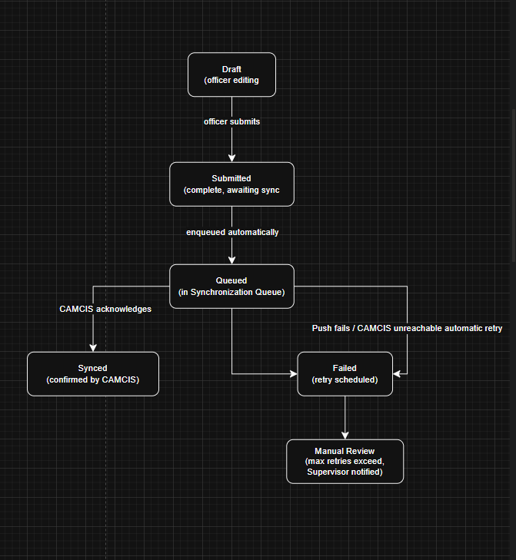
Figure 2.1: Report synchronisation lifecycle, illustrating the dependency between inspection completion and synchronisation.
Requirements analysis and design lead into backend development, which in turn enables mobile application development (search, map, inspection modules); the synchronisation mechanism depends on the inspection module; web dashboard development runs in parallel with mobile development and converges with it at the testing phase; testing and evaluation lead into final documentation and defence. The path from requirements and design through backend development, mobile development, synchronisation, testing, and final reporting constitutes the critical path, since any delay along this path directly delays project completion, whereas web dashboard development has schedule slack.

2.5.5.3.2 Top Level Task Report
At the top level, the project consists of four major streams of work: research and design, internship-informed development, testing and evaluation, and final documentation, corresponding respectively to milestones M1 to M3, M4 to M7, M8, and M9 to M10 in the table above.

2.5.5.3.3 Critical Task Report
The mobile application's core modules (search, map, inspection) and the synchronisation mechanism represent the critical tasks of the project, since dashboard testing and final evaluation depend on their successful completion. Given the compressed schedule between June and September 2026, delays in either task are expected to have the greatest impact on the overall project timeline and should therefore be prioritised and monitored most closely.

CHAPTER THREE: METHODOLOGY
This chapter describes the methodology followed in designing and developing DouaneNav. As the study focuses on designing a working software application the methodology is adapted to a systems-development context.

3.1 Research Design
This study follows a design science research approach, an approach widely used in software engineering and information systems research for studies whose primary output is a technological application evaluated against a real operational problem. The application in this study is the DouaneNav mobile subsystem itself; the 'problem' is the lack of intuitive destination visualisation and structured field-inspection support described in Chapter One; and 'evaluation' takes the form of feasibility assessment, functional testing, and usability review described later in this chapter and in Chapter Four.

3.2 Feasibility Studies

3.2.1 Market Study
As established in Chapter One's Justification (Section 1.7), no comparable mobile-first subsystem targeting destination visualisation and field-inspection support, built to complement CAMCIS, currently exists within the Cameroonian customs context. This supports the market case for the project, though it is worth noting the study does not involve a formal commercial market analysis, since DouaneNav is intended for internal operational use by Cameroon Customs rather than as a commercial product.

3.2.2 Environmental Feasibility
Cameroon's growing smartphone and internet penetration supports the feasibility of a mobile-first tool. At the host institution specifically, the working environment was found to be orderly and secure (Section 2.4.4), though internal digitalisation remains limited and some computers run outdated operating systems such as Windows 7, an environmental constraint relevant chiefly to any future desktop-based component of the system rather than to the mobile application itself.

3.2.3 Technical Feasibility
The technologies selected, React Native for the mobile application, React.js for the web dashboard, Node.js with Express for the backend, and MongoDB for the database, are mature, well documented, and widely used, reducing technical risk. The Google Maps SDK provides reliable geocoding and map rendering. Because direct CAMCIS integration is not available to the student, technical feasibility during development depends on the use of a simulated dataset, considered a reasonable and common approach for student projects working with secured government platforms.

3.2.4 Economic Feasibility
Development relies primarily on free or low-cost tiers of the technologies involved (open-source frameworks, and free usage tiers of the Google Maps SDK), with the main cost being the student's development time rather than licensing or infrastructure expenditure. A detailed cost estimate is presented in Chapter Five.

3.2.5 Socio-Political Feasibility
The project aligns with Cameroon Customs' own stated modernisation mandate under Decree No. 2013/066 (Section 2.3), and with the broader trajectory of customs digitisation already demonstrated by the PAGODE-to-SYDONIA-to-CAMCIS progression (Section 1.1.1), suggesting reasonable socio-political feasibility, though formal institutional adoption would require approval beyond the scope of this academic study.

3.2.6 Feasibility Report
Taken together, the feasibility studies above indicate that DouaneNav is feasible as an academic project within the stated constraints: technically achievable with mature, low-cost tools; economically modest in cost; environmentally supported by growing mobile penetration, notwithstanding internal digitalisation gaps at the host institution; and socio-politically aligned with the customs administration's own modernisation objectives.

3.3 System Development Methodology
Software development methodologies provide structured approaches for planning, designing, implementing, testing, and maintaining software systems. Different methodologies exist, each with advantages and limitations depending on the nature, complexity, and requirements of a project.
The following software development methodologies were considered for the development of DouaneNav:

3.3.1 Waterfall Methodology
The Waterfall methodology follows a sequential development process where each phase must be completed before moving to the next. The major phases include requirements analysis, system design, implementation, testing, deployment, and maintenance.
The main advantage of this approach is its clear documentation and structured planning. However, it has limited flexibility because changes introduced after a phase has been completed can be difficult and costly to implement. This makes it less suitable for projects where requirements may evolve during development.

3.3.2 Agile Methodology
Agile methodology focuses on continuous development through short iterations, regular feedback, and adaptation to changing requirements. Development is divided into smaller cycles where features are designed, implemented, tested, and improved progressively.
Agile provides flexibility and encourages frequent stakeholder involvement. However, it often requires continuous communication with stakeholders and a dedicated development team, which may be difficult in an individual academic project with limited time and resources.

3.3.3 Rapid Application Development (RAD)
Rapid Application Development emphasizes fast prototyping and user feedback. It focuses on creating working versions of the system quickly, allowing users to evaluate and suggest improvements before final implementation.
Although RAD supports fast development, it is more suitable for projects where users are continuously available for prototype evaluation and where the system requirements are not highly dependent on structured architecture.

3.3.4 Iterative and Incremental Methodology
The iterative and incremental methodology combines gradual development with continuous improvement. The system is developed in small functional increments, where each completed module is tested, reviewed, and improved before additional features are introduced.
This approach allows developers to manage complex systems by dividing them into manageable components while maintaining flexibility throughout development.

3.3.5 Choice of Methodology
The iterative and incremental methodology was selected for the development of DouaneNav because the system consists of several independent but interconnected modules, including authentication, dashboard management, declaration retrieval, destination visualization, inspection reporting, synchronization, and reporting.
Unlike the Waterfall approach, which requires all requirements to be finalized before development begins, the selected methodology allowed requirements to be refined progressively as the system evolved. This was particularly important because the project involved adapting concepts from existing applications, analysing customs operational requirements, and receiving validation throughout development.
Although Agile also supports iterative development, a complete Agile framework requires continuous stakeholder participation, regular sprint meetings, and a collaborative development environment. Due to the academic nature of this project and the limited availability of stakeholders, a lighter iterative and incremental approach was more appropriate.
Therefore, the iterative and incremental methodology provided the best balance between flexibility, structured progress, documentation requirements, and the practical constraints of this project.
The development process was divided into the following phases:
- Background research and requirement analysis
- System architecture and database design
- Backend implementation
- Mobile application development
- Web dashboard development
- Module testing and validation
- System refinement and final evaluation
Each phase produced a functional output that was reviewed before proceeding to the next phase.

3.4 Functional Requirements
Functional requirements describe the services that DouaneNav must provide to its users. The system was designed to satisfy the operational requirements of Cameroon Customs by allowing authorized personnel to securely access declaration information, verify destinations, perform inspections, and manage customs operations. They are
- User Authentication
- Dashboard Access
- Declaration Search
- Declaration Details
- Destination Visualization using Google Maps
- Inspection Management
- Inspection Report Generation
- AI Document Analysis Prototype (Future Enhancement)
- Data Synchronization
- User Management (Administrator only)

3.4.1 Role Played by Each Actor

Administrator
- Manage users
- View all declarations
- Monitor synchronization
- Access reports
- Configure the system
Supervisor
- Review inspections
- View reports
- Monitor officers
- Access dashboard
Customs Officer
- Search declarations
- Verify destination
- Perform inspection
- Create inspection reports
- View AI analysis results from the prototype module

3.5 Population of the Study
This study did not collect primary data from a sampled population; as explained in Section 3.6, the evidence supporting the problem statement and system requirements was drawn entirely from secondary, documentary sources. The populations described below are presented for context, identifying the intended beneficiaries of the eventual system, rather than as a population from which data was collected.

3.5.1 Mother Population
The broadest population relevant to this study is all Cameroon Customs personnel nationally who could conceivably use a destination-visualisation and field-inspection support tool, including Customs Officers across all customs offices and sectors.

3.5.2 Target Population
The target population is narrower: personnel at the Cameroon customs (Direction Générale des Douanes) headquarters in Yaounde, and specifically staff of the Technical Service, whose day-to-day work most directly informed the operational context of this study.

3.5.3 Accessible Population
No accessible population was sampled for primary data collection in this study. The Technical Service, within which the internship took place, is described in Section 2.4.1; its remit centres on regulation, technical support, and modernisation rather than front-line declaration processing, which further supports the decision to ground this study's evidence in documentary sources rather than in observation of a process the Technical Service does not itself routinely perform.

3.6 Sampling Frame
This study relies entirely on secondary documentary data rather than data collected from human respondents. Therefore, a conventional sampling frame and sample size were not applicable. The documents used in this study were selected purposively based on their relevance, authority, and direct contribution to understanding customs procedures, digitalisation, and system requirements.
The selected sources included official Cameroon Customs documentation, government regulations, UNCTAD documentation on customs automation, and an independently published report from the Cameroon Economic Policy Institute (CEPI). These sources were reviewed in full and used to establish the problem context, derive system requirements, and support the design of DouaneNav.

3.7 Sources of Data Collection

3.7.1 Primary Data
This study did not collect primary data through interviews, questionnaires, or direct observation. The field supervisor's guidance and the internship placement (Section 2.4) provided general contextual and institutional familiarity with Cameroon Customs' working environment, but this exposure is not presented as evidence for any specific claim in this report. Every substantive claim made about customs procedure, including the practice of cross-referencing multiple documents during declaration verification, is instead supported directly by the secondary documentary sources listed below, a deliberate choice explained further in Section 3.7.1.

3.7.2 Secondary Data
Secondary data was drawn from official CAMCIS and Cameroon Customs documentation, Decree No. 2013/066 of 28 February 2013, the Cameroon Economic Policy Institute's (CEPI, 2024) report on import and export procedures in Cameroon, UNCTAD documentation on the ASYCUDA Programme, and the academic and theoretical literature reviewed in Chapter Two. The CEPI (2024) report in particular provides an independently produced, procedural account confirming that a customs declaration must be verified against a defined bundle of supporting documents, directly corroborating the problem this study addresses without requiring first-hand observation of the process.

3.8 Validity and Reliability of the Instrument

3.8.1 Validity of the Instrument
A purely documentary methodology was adopted in preference to informal discussion or unstructured observation for a specific reason: the Technical Service, where the internship took place, is not itself responsible for front-line declaration verification (Section 2.4.1), so any observation conducted there would have been incidental rather than representative, and any informal discussion with staff would not constitute a validated research instrument. Grounding the problem statement instead in official, published, and independently authored documentary sources, a government decree, the customs administration's own reform documentation, and an independent economic policy institute's procedural account, provides a more defensible evidentiary basis than either alternative, since each source can be independently verified by a reader and was not filtered through the researcher's own recollection or a single conversation.

3.8.2 Reliability of the Instrument
Reliability is a particular strength of a documentary approach: because the sources relied upon are fixed, published documents rather than data generated through a live interview or observation session, any subsequent reviewer consulting the same sources would obtain the same information. This avoids the reliability concerns inherent in real-time data collection instruments, such as an interviewer's phrasing or an observer's attention, which depend on conditions specific to the moment of data collection.

3.9 Method of Data Analysis
Documentary analysis was applied to the secondary sources described in Section 3.6.2, identifying and synthesising the specific passages describing customs declaration verification procedures, in particular the practice of cross-referencing a declaration against its accompanying bill of lading, invoice, and packing list, which directly informed the problem statement and functional requirements presented in Chapter One. This analysis is fully traceable to named, citable sources (Section 2.3) rather than to the researcher's own field notes or recollection. For system evaluation, standard software testing methods, unit testing of individual functions, functional testing of each module, and informal user-acceptance review with the field supervisor, are applied and reported in Chapter Four.

3.9.1 Results of Documentary Data Analysis
The documentary analysis conducted from the selected secondary sources provided the evidence used to define the problem addressed by this study and derive the functional requirements of DouaneNav. The reviewed documents were analysed to identify information related to customs declaration processing, digitalisation of customs operations, and the requirements for improving access to shipment information during field activities.
The analysis produced the following findings:
Source | Evidence Identified | Contribution to DouaneNav Design
Cameroon Economic Policy Institute (CEPI, 2024) report on import and export procedures in Cameroon | Customs clearance procedures require verification of information contained in multiple supporting documents, including transport documents, commercial invoices, and packing lists accompanying the customs declaration. | Supports the need for a system that retrieves declaration information and presents important shipment details in a more accessible manner.
Cameroon Customs and CAMCIS documentation | The CAMCIS platform provides electronic management of customs declarations and contributes to the digital transformation of customs operations. | Supports the development of DouaneNav as a complementary subsystem that works alongside CAMCIS rather than replacing it.
UNCTAD documentation on ASYCUDA customs systems | Modern customs environments require digital information management, data exchange, and improved accessibility of customs information. | Supports the implementation of synchronisation mechanisms and digital inspection reporting.
Decree No. 2013/066 of 28 February 2013 relating to the organisation of Cameroon Customs | Defines the responsibilities and organisational structure of Cameroon Customs administration. | Provides the institutional context for identifying the intended users of the system, including Customs Officers, Supervisors, and Administrators.
The findings obtained from this documentary analysis directly informed the system requirements presented in Section 3.3. In particular, the identified need for improved access to declaration information, destination verification, and structured inspection reporting guided the development of the main modules of DouaneNav, including Declaration Management, Destination Visualisation, Inspection Management, and Synchronisation.

3.10 Method of Project Analysis
The analysis and design of DouaneNav were carried out using standard software engineering modeling techniques. Before implementation, the system was represented using Unified Modeling Language (UML) diagrams and an Entity Relationship Diagram (ERD). These models provided a visual representation of the system requirements, user interactions, workflows, object relationships, and database structure. They also served as a blueprint during implementation by ensuring that every functional requirement identified during the analysis phase was correctly translated into software components.
The following subsections present the design models developed for the project.

3.10.1 Use Case Diagram
The Use Case Diagram provides a high-level overview of the interactions between the users of DouaneNav and the system. It identifies the different actors involved and the services each actor can perform according to their responsibilities.
The system has three main actors:
- Administrator
- Supervisor
- Customs Officer
Each actor interacts with specific system functions such as authentication, declaration management, destination verification, inspection management, report generation, synchronization, and user administration.
The diagram helps define the functional boundaries of the system and ensures that every user role has access only to the operations assigned to it.
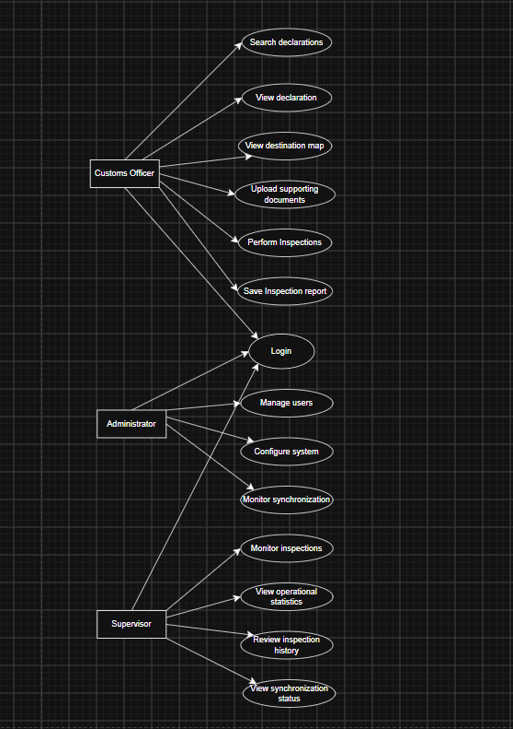
Figure 3.1: Use Case Diagram

3.10.2 Sequence Diagram
Sequence Diagrams describe the interaction between system components over time. They illustrate the chronological order in which requests are exchanged between the user interface, backend services, business logic, and database.
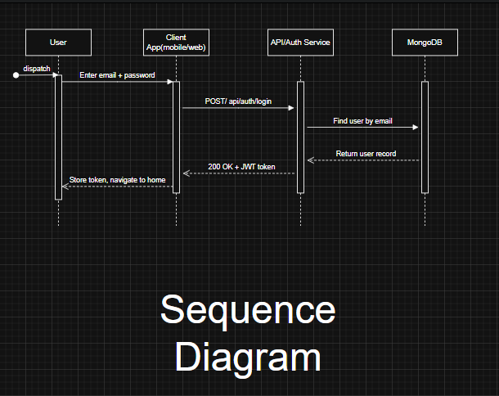
Figure 3.2: Login Sequence Diagram

3.10.3 Class Diagram
The Class Diagram illustrates the static structure of DouaneNav by showing the major classes that make up the application, together with their attributes, methods, and relationships.
The diagram includes the principal entities used during development, such as:
- User
- Declaration
- Inspection
- Report
- AIAnalysis
- SynchronizationLog
It also illustrates the relationships between the service layer, repositories, controllers, and domain models developed using the Clean Architecture adopted for the project.
The Class Diagram served as the blueprint for implementing the backend components and organizing the application into reusable and maintainable modules.
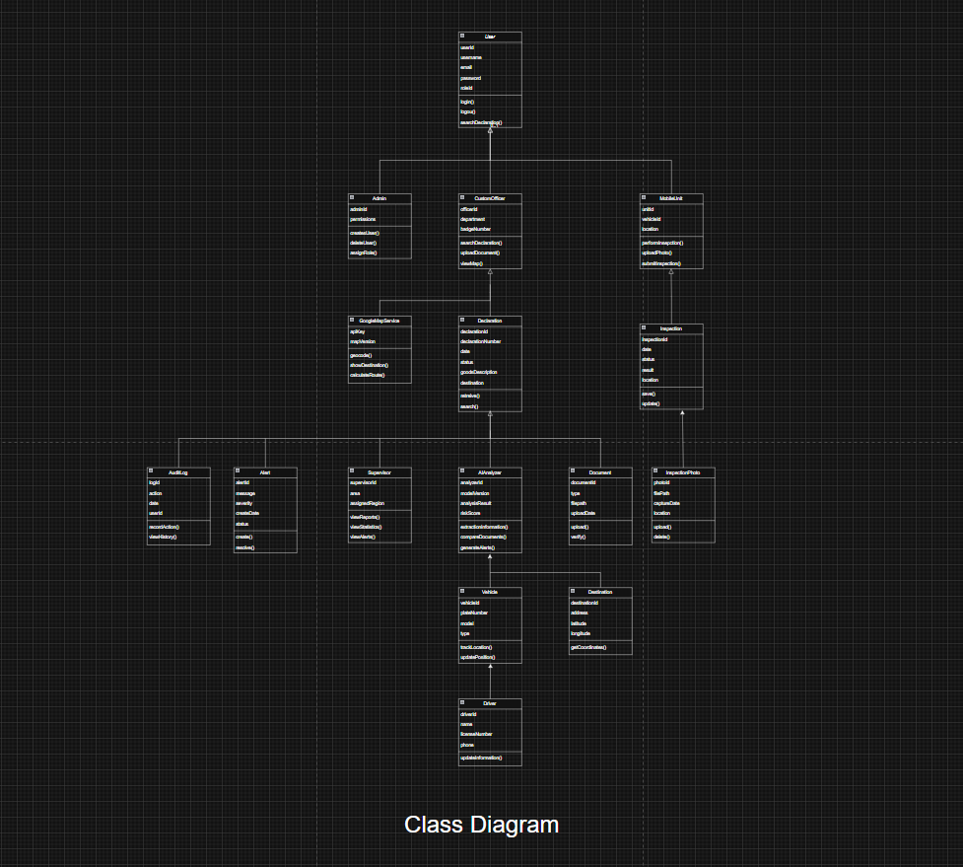
Figure 3.3: Class Diagram

3.10.4 Entity Relationship Diagram (ERD)
The Entity Relationship Diagram illustrates the logical organisation of MongoDB collections and the relationships between the data entities used by the system.
The principal entities represented include:
- Users
- Declarations
- Inspections
- Reports
- AIAnalysis
- SynchronizationLogs
- AuditLogs
The ERD was developed to ensure data consistency, minimize redundancy, and facilitate efficient retrieval of customs declaration information during system operation.
Although MongoDB is a NoSQL database, the ERD provides a conceptual representation of how the collections are related and how information flows throughout the application.
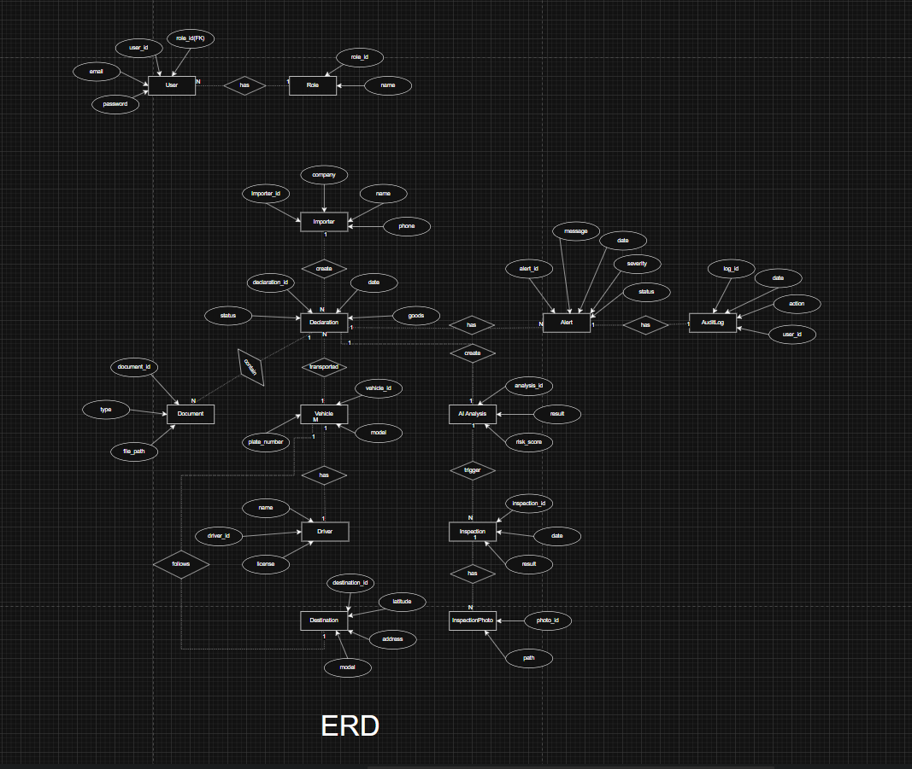
Figure 3.7: Entity Relationship Diagram (ERD)

CHAPTER FOUR: PRESENTATION OF SYSTEM IMPLEMENTATION AND RESULTS
This chapter presents the results of the development and implementation of DouaneNav: Destination Visualization and Verification System for Customs Goods. It focuses on the functionality of the developed system, the user interface, the interaction between the different system users, and the results obtained from testing each module. The chapter demonstrates how the various components work together to support customs officers in visualizing declared destinations, managing declarations, conducting inspections, generating reports, displaying prototype AI-assisted analysis results, and synchronizing data. Screenshots of the implemented interfaces are presented to illustrate the operation of each module and to demonstrate that the system meets the objectives defined in Chapter One.
The documentary analysis findings presented in Section 3.8.1 informed the functional requirements and design decisions implemented in the system. The following sections present the implementation and testing results of the developed application.

4.1 Presentation of Descriptive Statistics
In place of survey response frequencies, this section presents two kinds of descriptive data appropriate to a systems-development study: the implementation status of each of the eight planned modules, and the results of the automated tests run against the modules completed so far.

4.1.1 Development Status Overview
Number | Module | Key Components | Status
1 | Authentication | Login, Logout, JWT issuance, role-based access control, 4 seeded roles | Complete
2 | Dashboard | Statistics, alerts, recent inspections, synchronisation status summary | Complete
3 | Declarations | List, search, filters, details, documents | Complete
4 | Google Maps | Destination marker, geocoding, route preview | Complete
5 | AI Module | Mock document analysis, destination extraction, inconsistency detection | Complete prototype only
6 | Inspection Module | Create inspection, photos, comments, status, history | Complete
7 | Synchronisation Module | Simulated sync, queue, sync history, CAMCIS reference | Complete
8 | Reports | Daily reports, officer activity, inspection history, export | Complete

Development follows Clean Architecture, per the Software Architecture document: routes delegate to controllers, controllers delegate to services, and services alone interact with the MongoDB models, so each module can be built, tested, and verified independently before the next begins.

4.1.2 Module 1 (Authentication)
The authentication module provides secure access to the system through role-based login, session management and password recovery interfaces. The following screenshots demonstrate the authentication workflow implemented for both the mobile application and the web dashboard, including successful login, validation of invalid credentials, and password recovery pages.
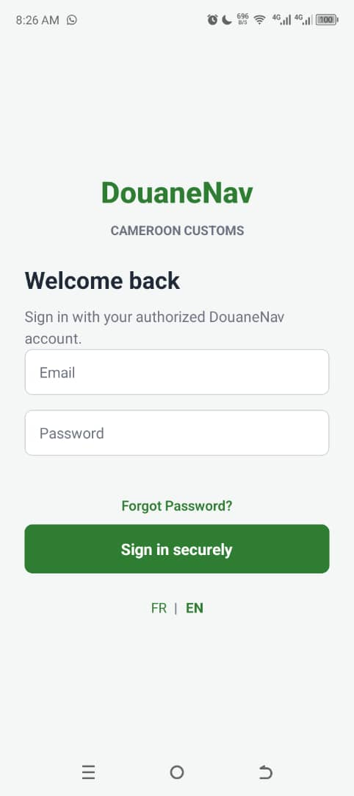
Figure 4.1 — Login page

4.1.3 Automated Test Results
Automated tests were written and run against Module 1, covering both the underlying authentication logic (password hashing, JWT generation and verification, and the RBAC middleware's decision logic) and the HTTP layer (route wiring, input validation, and access control on protected endpoints). All tests passed.
Test Category | Tests Run | Passed | Failed | Pass Rate
Password hashing (scrypt) | 3 | 3 | 0 | 100%
JWT token generation/verification | 4 | 4 | 0 | 100%
RBAC middleware (role/permission guards) | 5 | 5 | 0 | 100%
API routing | 3 | 3 | 0 | 100%
Input validation | 2 | 2 | 0 | 100%
Authorization (protected routes) | 2 | 2 | 0 | 100%
TOTAL | 19 | 19 | 0 | 100%

4.1.4 Modules 2–8
The following figures present the principal interfaces developed for the DouaneNav mobile application. Together, they illustrate the complete workflow of the proposed system, beginning with user dashboard, followed by declaration management, destination verification, inspection reporting, and synchronisation. Each screenshot demonstrates the corresponding functionality implemented during system development and provides visual evidence of the application's operation.

Module 2 — Dashboard
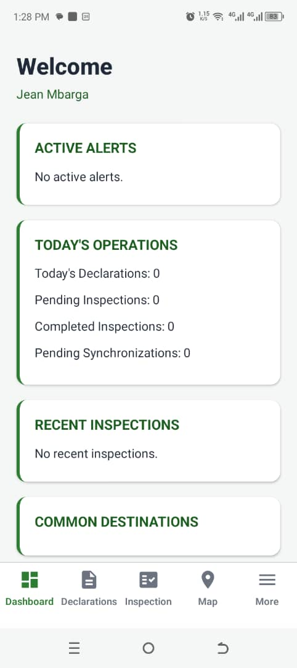
Figure 4.2 — Dashboard

Module 3 — Declarations
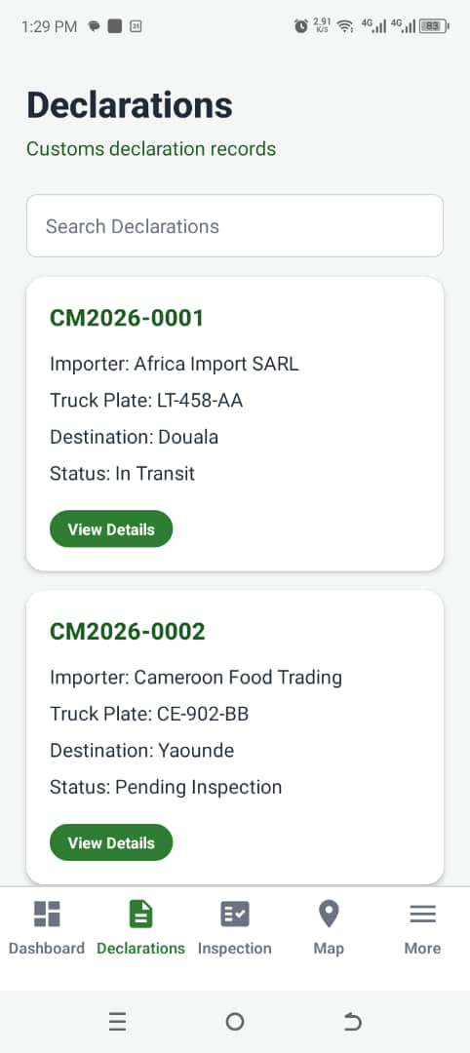
Figure 4.3 — Declaration search results list

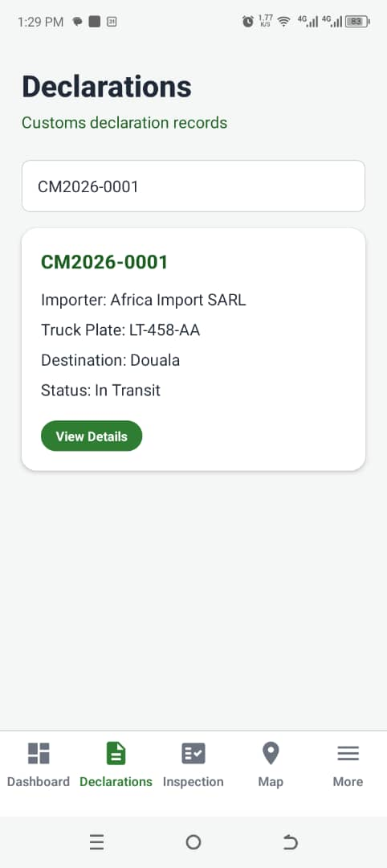
Figure 4.4 — Search by declaration number

Module 4 — Google Maps
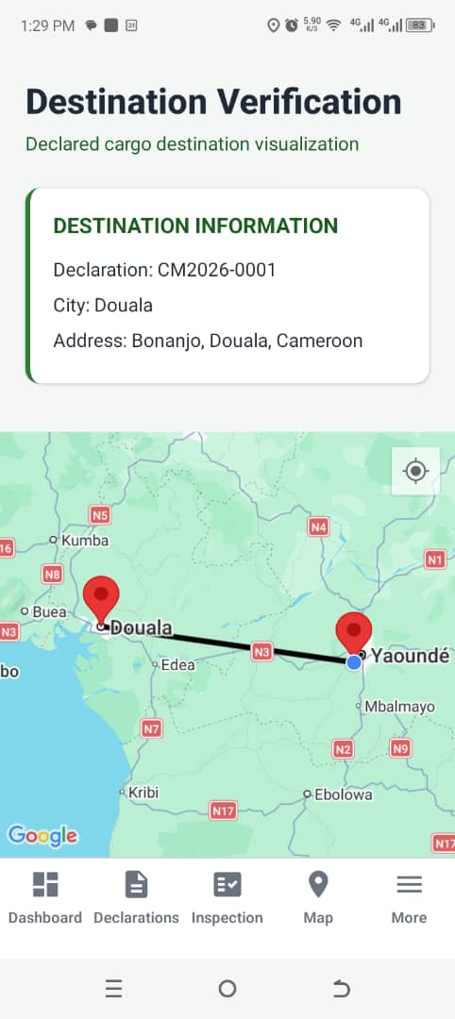
Figure 4.5 Full map screen with destination marker

Module 5 — AI Module (Mock)
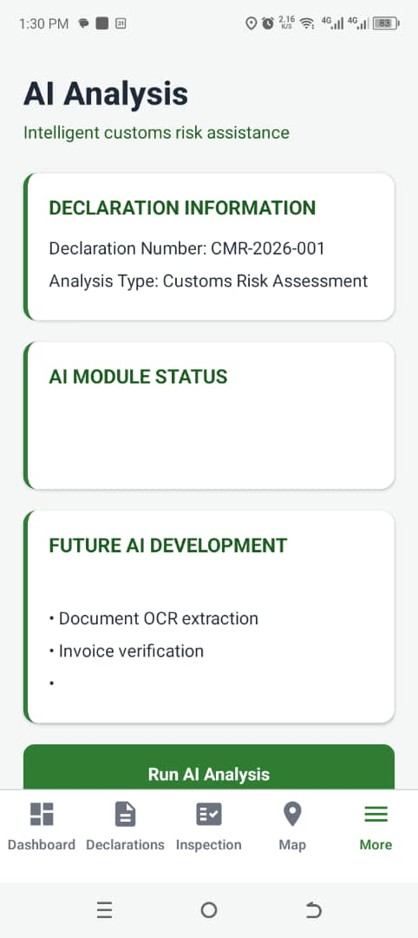
Figure 4.6 — Mock AI analysis result

Module 6 — Inspection Module
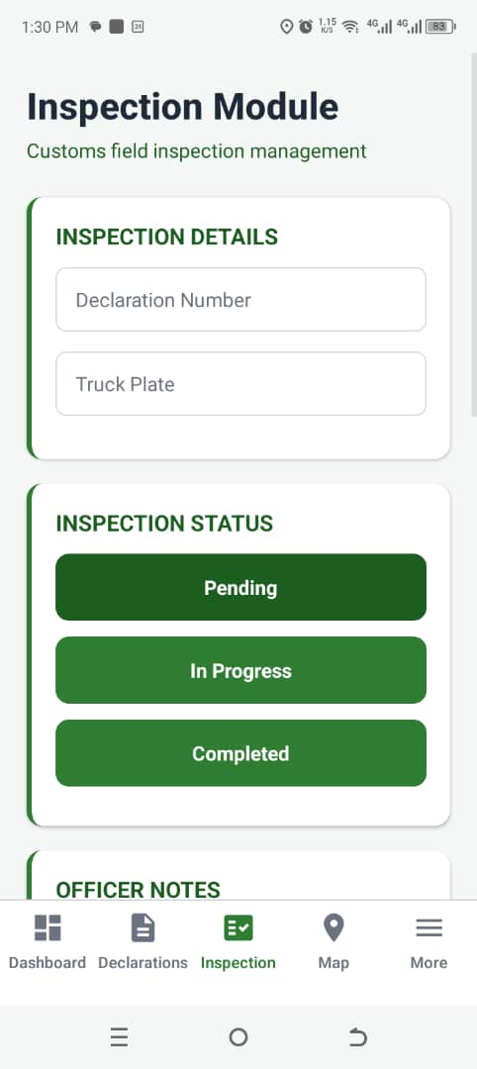
Figure 4.7 — Inspection form

Module 7 — Synchronisation Module
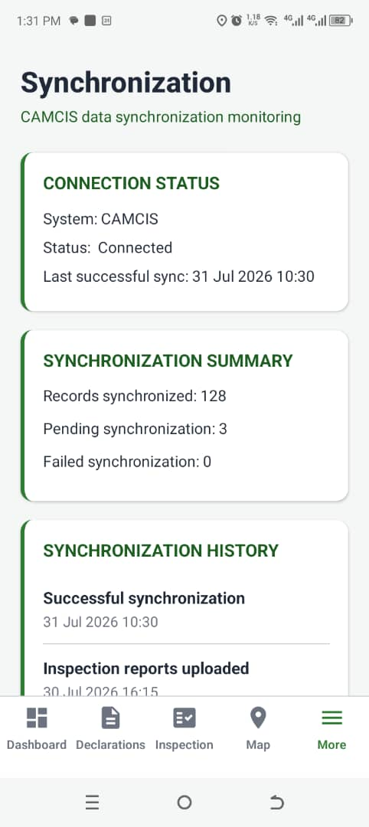
Figure 4.8 — Synchronisation

Module 8 — Reports
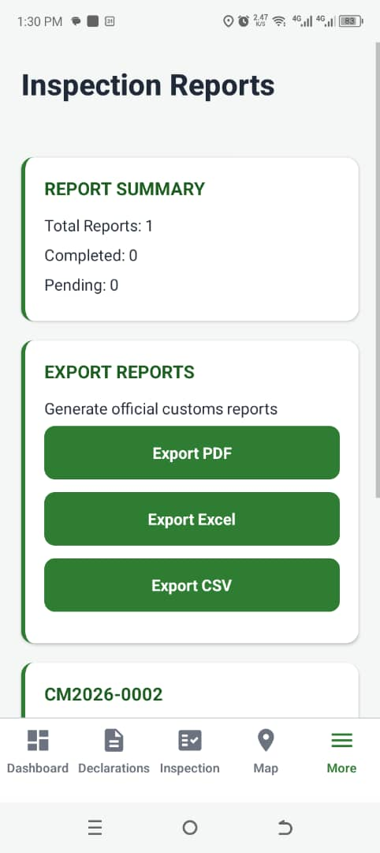
Figure 4.9 — Report page

CHAPTER FIVE

DISCUSSION, CONCLUSION AND RECOMMENDATIONS

5.1 Discussion of Findings
The primary objective of this project was to develop a mobile-based decision support system capable of assisting Cameroon Customs Officers in verifying declared cargo destinations through map visualisation, structured inspection reporting, and synchronisation with an administrative monitoring platform. The completed system successfully achieved the implemented objectives defined for this study, while AI-based document analysis remains a prototype and future enhancement.
The authentication module provides secure role-based access control for Customs Officers, Supervisors, and Administrators. Declaration records can be retrieved and searched efficiently, allowing officers to quickly access relevant shipment information. The destination verification module integrates Google Maps to display declared destinations, thereby improving the visualisation of cargo movement compared with traditional text-based declaration records.
The inspection module enables officers to capture structured inspection reports, attach photographic evidence, and record inspection observations using mobile devices. The synchronisation module ensures that inspection records are transmitted to the administrative dashboard whenever network connectivity is available, reducing delays associated with manual reporting. The reporting module further supports operational monitoring by presenting completed inspection records in an organised manner.
Although the Artificial Intelligence module was implemented as a mock component, the system architecture was designed to support future integration of AI-based document analysis and risk assessment without requiring significant architectural modifications.
Overall, the findings demonstrate that the developed system satisfies the functional requirements established during the analysis and design phases and provides a practical digital solution for customs destination verification and inspection management.

5.2 Discussion of the Project Plan
The project was executed following the implementation plan established during the system design phase. Development was organised into independent modules, allowing each component to be implemented, tested, and validated before progressing to the next stage.
The implementation sequence consisted of:
- Authentication and Role-Based Access Control
- Dashboard Development
- Declaration Management
- Destination Verification using Google Maps
- AI Module Prototype
- Inspection Management
- Synchronisation Services
- Reporting Module
- Administrative Web Dashboard
This modular development approach simplified debugging, improved maintainability, and ensured that individual components could be tested independently before integration into the complete system.
Several refinements were introduced during development, including interface improvements, multilingual support (English and French), improved synchronisation feedback, and enhanced inspection report presentation. These modifications strengthened the usability of the final application while remaining within the project's original objectives.

5.3 Project Closeout Decision
The project has successfully achieved its intended objectives and is considered technically feasible for deployment within the operational environment of Cameroon Customs after appropriate institutional approval and integration with the existing CAMCIS infrastructure.
The developed prototype demonstrates that customs destination verification, inspection reporting, synchronisation, and administrative monitoring can be digitised using a mobile-first architecture without disrupting existing customs workflows.
Although some advanced features—including live routing, AI-powered document analysis, and automated export services—remain future enhancements, the implemented system already provides a functional foundation capable of supporting customs inspection activities.
Consequently, the project is considered feasible for future deployment and further development.

5.4 Conclusion
This project successfully designed and implemented DouaneNav, a mobile-based destination verification and inspection management system for Cameroon Customs.
The system provides secure authentication, declaration management, destination visualisation through Google Maps, structured inspection reporting, synchronisation capabilities, reporting functions, and administrative monitoring through a complementary web dashboard. These features contribute to improving inspection efficiency, reducing dependence on paper-based processes, and supporting more informed decision-making during customs operations.
Furthermore, the modular architecture adopted during development provides flexibility for future enhancements, including Artificial Intelligence, advanced analytics, automated routing, and direct integration with CAMCIS.
The project therefore demonstrates that modern mobile technologies can significantly improve customs field operations while providing a scalable platform for future digital transformation initiatives.

5.5 Policy Implication
The successful implementation of DouaneNav demonstrates the potential benefits of adopting mobile digital technologies within Cameroon Customs operations.
Government agencies responsible for customs administration may consider integrating mobile inspection systems into existing customs information infrastructures in order to improve operational efficiency, increase transparency, strengthen inspection documentation, and reduce reliance on manual reporting procedures.
The project also supports national digital transformation initiatives by illustrating how mobile technologies, geographical information systems, and structured digital reporting can improve public sector service delivery.
Future integration with CAMCIS could further strengthen customs monitoring, improve cargo destination verification, and facilitate more effective coordination between customs officers and supervisory personnel.

5.6 Recommendations
The following recommendations are proposed for future improvement of the system:
- Integrate the application directly with the official CAMCIS database to eliminate reliance on simulated declaration data.
- Implement AI-powered document verification capable of analysing customs documents, identifying inconsistencies, and generating automated risk assessments.
- Integrate real road routing and navigation services to provide officers with optimal driving routes during destination verification.
- Implement PDF, Excel, and CSV export functionality for inspection reports and administrative records.
- Introduce push notifications to inform supervisors whenever new inspection reports are synchronised.
- Implement offline map caching to improve destination verification in remote areas with limited internet connectivity.
- Expand the reporting module with advanced statistical dashboards and operational analytics.
- Conduct pilot testing within selected Cameroon Customs offices to evaluate usability, performance, and operational impact under real working conditions.

REFERENCES
Cameroon Economic Policy Institute. (2024). Report: Import & export procedure and documentation in Cameroon. Henri Kouam Foundation. www.camepi.org
Direction Générale des Douanes. (n.d.-a). Missions des douanes camerounaises. Ministère des Finances du Cameroun.
Direction Générale des Douanes. (n.d.-b). Réforme et modernisation de l'administration des douanes. Ministère des Finances du Cameroun.
Gorry, G. A., & Scott Morton, M. S. (1971). A framework for management information systems. Sloan Management Review, 13(1), 55–70.
International Trade Administration. (2026). Cameroon: Customs regulations. U.S. Department of Commerce.
Republic of Cameroon. (2013). Décret n° 2013/066 du 28 février 2013 portant organisation du Ministère des Finances. Décret n.2013/066 du 28 février 2013 portant sur l'organisation du Ministère des Finances. | InforMEA
Simon, H. A. (1947). Administrative behavior: A study of decision-making processes in administrative organization. Macmillan.
United Nations Conference on Trade and Development. (2025). ASYCUDA Programme annual report 2025. Customs automation - ASYCUDA | UN Trade and Development (UNCTAD)
Google. (2025). Google Maps Platform documentation. https://developers.google.com/maps/documentation
MongoDB Inc. (2025). MongoDB documentation. https://www.mongodb.com/docs/
Node.js Foundation. (2025). Node.js documentation. https://nodejs.org/docs/latest/api/
OpenStreetMap Contributors. (2025). OpenStreetMap. https://www.openstreetmap.org/
React. (2025). React documentation. https://react.dev/
React Native. (2025). React Native documentation. https://reactnative.dev/docs/getting-started
Republic of Cameroon. (2001). Law No. 2001/015 of 23 July 2001 establishing the Cameroon Customs Code.
Republic of Cameroon. (2023). Cameroon Customs Administration. https://www.douanes.cm/
Shankar, V., Kleijnen, M., Ramanathan, S., Rizley, R., Holland, S., & Naaz, F. (2012). Location-based services: Opportunities and risks for marketing. Journal of Interactive Marketing, 26(4), 249–258. https://doi.org/10.1016/j.intmar.2012.05.001
World Customs Organization. (2021). WCO Data Model. https://www.wcoomd.org/

APPENDIX

DEFINITION OF TECHNICAL TERMS

Framework:
A collection of libraries, tools, and predefined structures that provide a foundation for developing software applications efficiently.

API (Application Programming Interface):
A set of rules that allows different software systems to communicate and exchange data.

Authentication:
The process of verifying the identity of a user before allowing access to a system.
Authorization:
The process of controlling the actions a user can perform based on assigned permissions or roles.
Database:
An organised collection of data stored electronically for efficient access and management.
Geocoding:
The process of converting a location name into geographic coordinates used for map display.
JWT (JSON Web Token):
A secure token used for maintaining authenticated communication between a client application and a server.
Role-Based Access Control (RBAC):
A security mechanism where system permissions are assigned according to user roles.
Synchronisation:
The process of transferring and updating information between different systems.
Repository:
A central location where project files, source code, and version history are stored.

SYSTEM SCREENSHOTS

Web Dashboard Screenshots

Administrator Dashboard
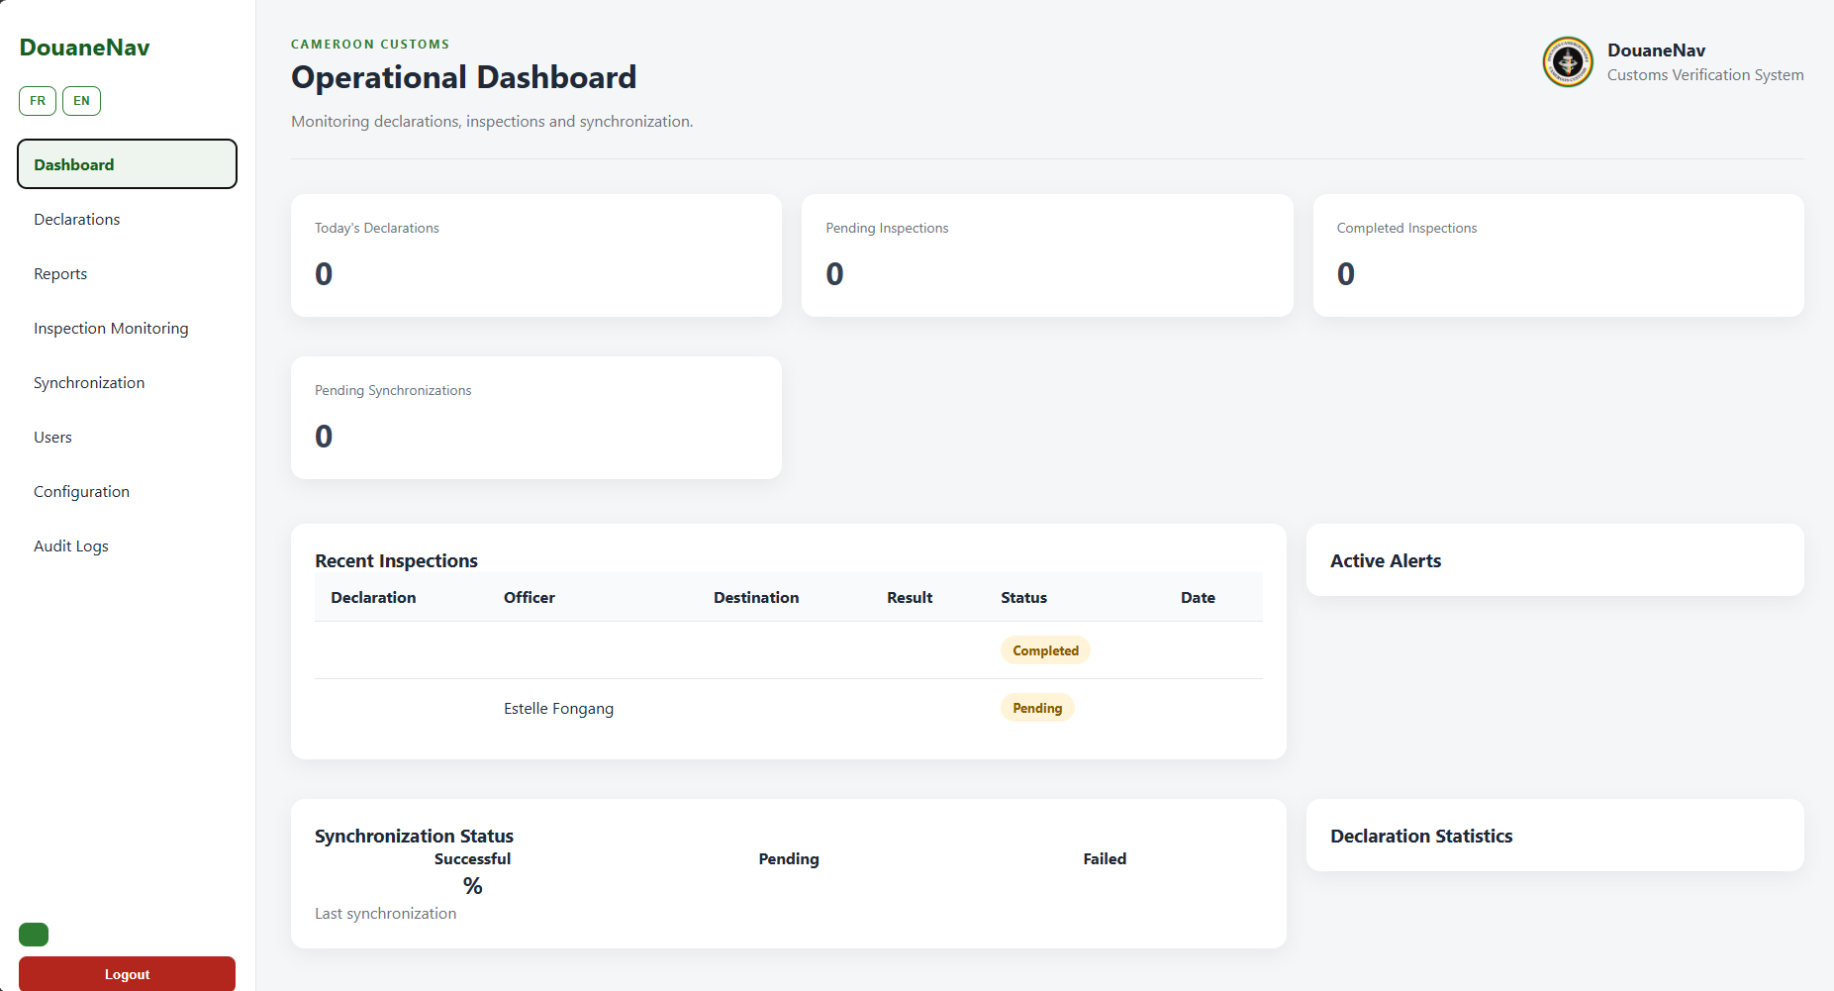

User Management Interface
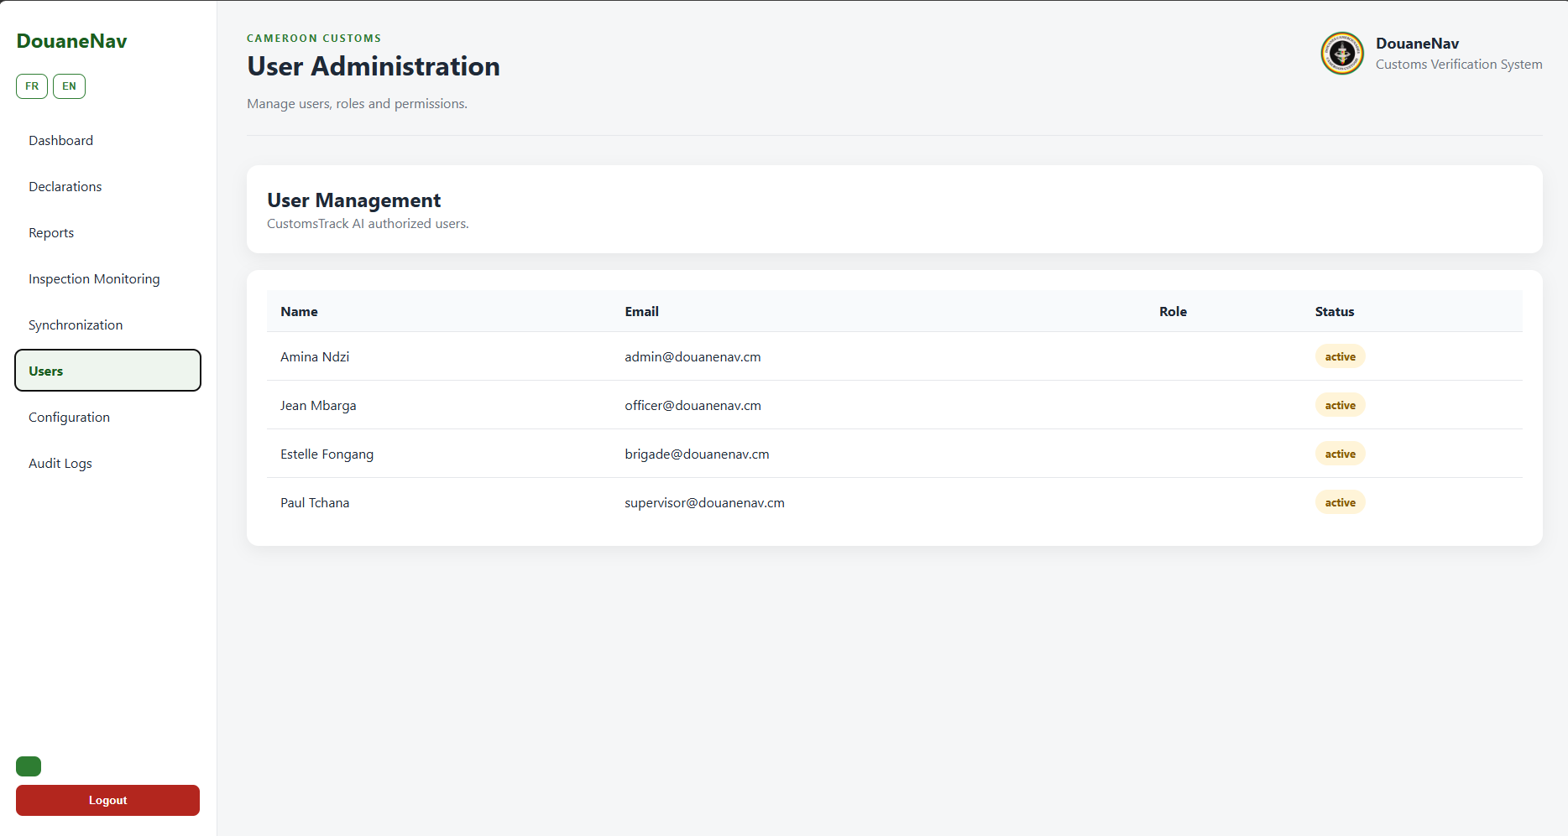

Technology Stack
Component | Technology
Mobile Application | React Native (Expo)
Web Dashboard | React.js
Backend API | Node.js + Express + TypeScript
Database | MongoDB
Authentication | JWT + scrypt
Mapping Service | Google Maps SDK
Architecture | Clean Architecture

